**Activity: Databases**

**Activity Task 1: University Database Schema**

**Define the Problem:**

Design a database for a university to manage students, courses, and professors.

**Steps to Complete the Task:**

1. Identify the tables: Students, Courses, Professors.
2. Decide on the columns for each table.
3. Connect the tables with relationships:
   * Each professor can teach many courses, but a course is taught by one professor (One-to-Many).
   * Each student can enroll in many courses, and each course can have many students (Many-to-Many).

**Solution:**

**1. Tables and Attributes**

**Students**

* StudentID (PK) – unique student identifier;
* FirstName – first name;
* LastName – last name;
* Email – email address;
* DateOfBirth – date of birth;
* Major – student’s major.

**Professors**

* ProfessorID (PK) – unique professor identifier;
* FirstName – first name;
* LastName – last name;
* Email – email address;
* Department – department name.

**Courses**

* CourseID (PK) – unique course identifier;
* Title – course title;
* Credits – number of credits;
* ProfessorID (FK) – reference to professor (One-to-Many: one professor → many courses).

**Enrollments (junction table for Many-to-Many)**

* EnrollmentID (PK) – unique enrollment record;
* StudentID (FK) – reference to student;
* CourseID (FK) – reference to course;
* Grade – grade (nullable until course completion).

**2. Relationships**

* Professors → Courses: one professor can teach many courses, but each course is taught by one professor (One-to-Many).
* Students ↔ Courses (via Enrollments): A student can enroll in many courses, and each course can have many students (Many-to-Many).

**3. ER Diagram**

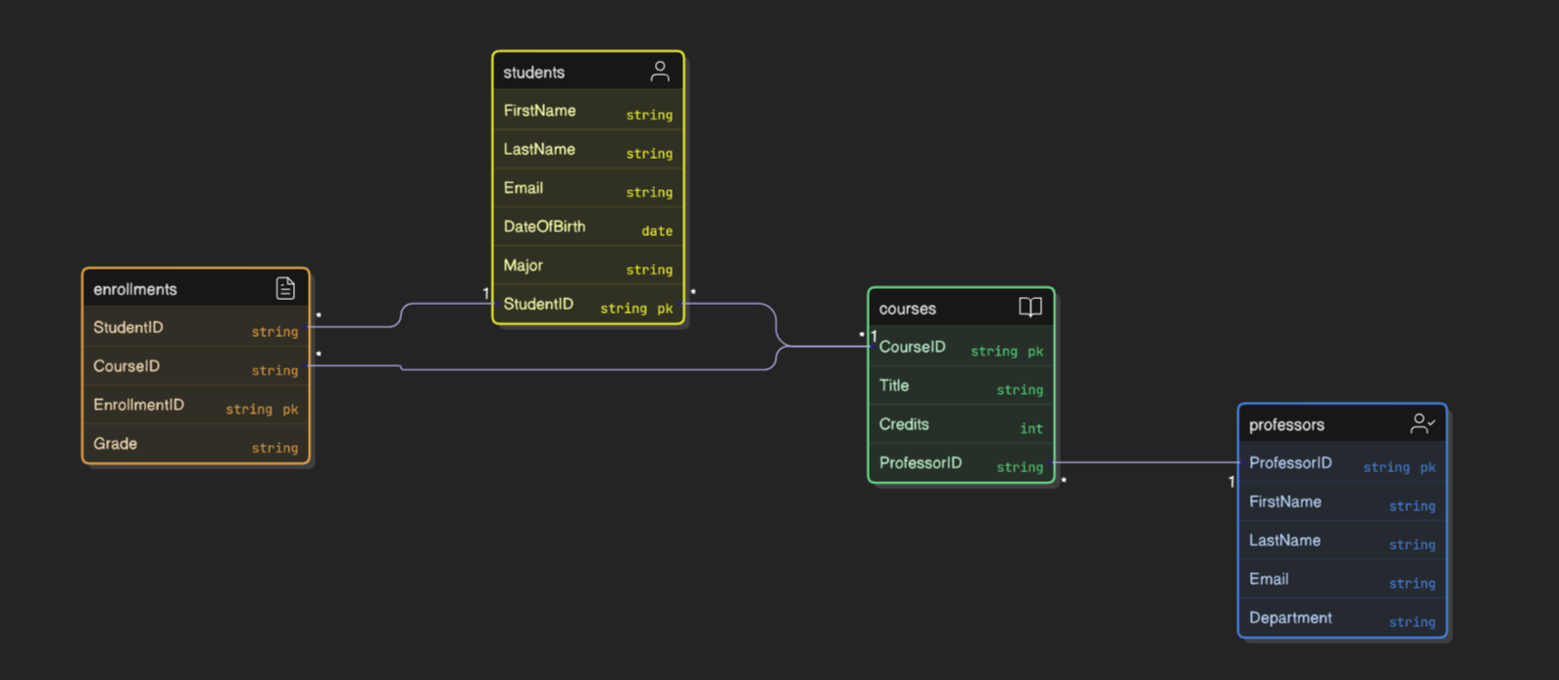

1. **SQL Script (DDL)**

**CREATE** **TABLE** Students (

StudentID INT **PRIMARY** **KEY**,

FirstName VARCHAR(**50**),

LastName VARCHAR(**50**),

Email VARCHAR(**100**) **UNIQUE**,

DateOfBirth DATE,

Major VARCHAR(**100**)

);

**CREATE** **TABLE** Professors (

ProfessorID INT **PRIMARY** **KEY**,

FirstName VARCHAR(**50**),

LastName VARCHAR(**50**),

Email VARCHAR(**100**) **UNIQUE**,

Department VARCHAR(**100**)

);

**CREATE** **TABLE** Courses (

CourseID INT **PRIMARY** **KEY**,

Title VARCHAR(**100**),

Credits INT,

ProfessorID INT,

**FOREIGN** **KEY** (ProfessorID) **REFERENCES** Professors(ProfessorID)

);

**CREATE** **TABLE** Enrollments (

EnrollmentID INT **PRIMARY** **KEY**,

StudentID INT,

CourseID INT,

Grade CHAR(**2**),

**FOREIGN** **KEY** (StudentID) **REFERENCES** Students(StudentID),

**FOREIGN** **KEY** (CourseID) **REFERENCES** Courses(CourseID)

);

**Activity Task 2: Library Management Schema**

**Define the Problem:**

Design a database for a library to manage members, books, and loans.

**Steps to Complete the Task:**

1. Identify the tables: Members, Books, Loans.
2. Decide on the columns for each table.
3. Connect the tables with relationships:
   * A loan connects a member to a book (One-to-Many).
   * A book can be borrowed many times by different members (Many-to-Many).

**Solution:**

**1. Tables and Attributes**

**Members**

* MemberID (PK) – unique member identifier;
* FirstName – first name;
* LastName – last name;
* Email – email address (unique);
* Phone – phone number;
* DateJoined – date when member joined.

**Books**

* BookID (PK) – unique book identifier;
* Title – book title;
* Author – author of the book;
* ISBN – international book number (unique);
* PublishedYear – year of publication;
* CopiesAvailable – number of available copies.

**Loans (junction table for Many-to-Many)**

* LoanID (PK) – unique loan identifier;
* MemberID (FK) – reference to member;
* BookID (FK) – reference to book;
* LoanDate – date when book was borrowed;
* DueDate – due date for return;
* ReturnDate – actual return date (nullable).

**2. Relationships**

* Members → Loans: One member can have many loans (One-to-Many);
* Books → Loans: One book can appear in many loans (One-to-Many);
* Members ↔ Books (via Loans): A member can borrow many books, and each book can be borrowed by many members (Many-to-Many, resolved by Loans).

**3. ER Diagram**

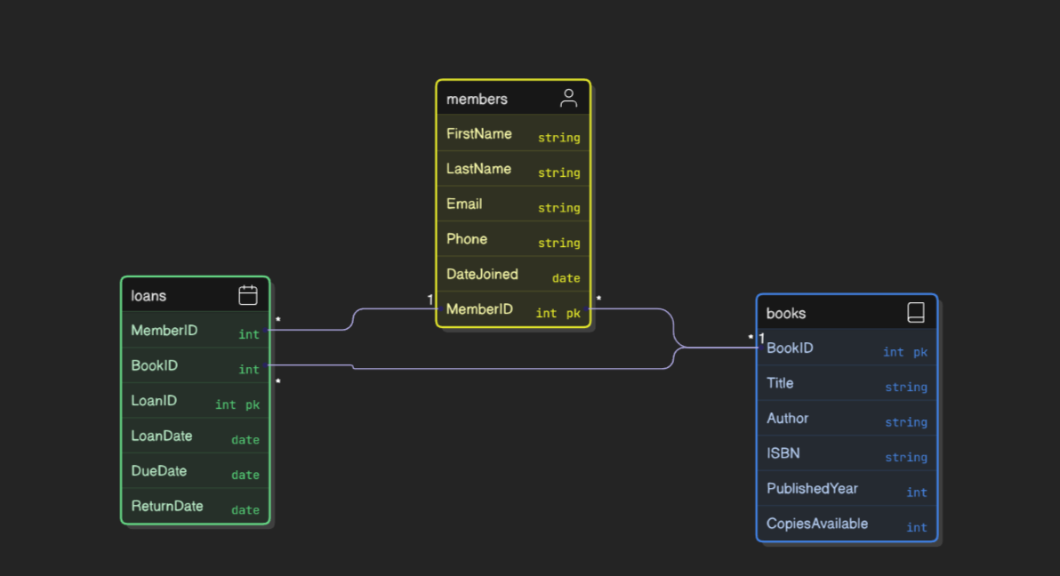

1. **SQL Script (DDL)**

**CREATE** **TABLE** Members (

MemberID INT **PRIMARY** **KEY**,

FirstName VARCHAR(**50**),

LastName VARCHAR(**50**),

Email VARCHAR(**100**) **UNIQUE**,

Phone VARCHAR(**20**),

DateJoined DATE

);

**CREATE** **TABLE** Books (

BookID INT **PRIMARY** **KEY**,

Title VARCHAR(**150**),

Author VARCHAR(**100**),

ISBN VARCHAR(**20**) **UNIQUE**,

PublishedYear INT,

CopiesAvailable INT

);

**CREATE** **TABLE** Loans (

LoanID INT **PRIMARY** **KEY**,

MemberID INT **NOT** **NULL**,

BookID INT **NOT** **NULL**,

LoanDate DATE **NOT** **NULL**,

DueDate DATE **NOT** **NULL**,

ReturnDate DATE,

**FOREIGN** **KEY** (MemberID) **REFERENCES** Members(MemberID),

**FOREIGN** **KEY** (BookID) **REFERENCES** Books(BookID)

);